**PROJECT REPORT**

# TITLE NAME:*CHARTING THE COURSE OF INNOVATION:A STARTUP ANALYSIS*

# 1.INTRODUTION:

# 1.1. OVERVIEW

The company overview is the part of your business plan that gives the basics and background of your business. It’s the foundation on which you will build the rest of your business plan. If you’re looking to appeal to investors or potential clients ,you need a reader to make an informed decision about your company.

A company in the early stages of development set up by one or several individuals to enter an existing market and with unique products or services

# 1.2. PURPOSE

A startup analysis is essential to the success of any startup business . It allows entrepreneurs to identify the key areas that need improvement and make necessary changes early on. The most small businesses might intend to stay small ,a startup focuses on fast growth in a design market.

**2.PROBLEM DEFINITION:** 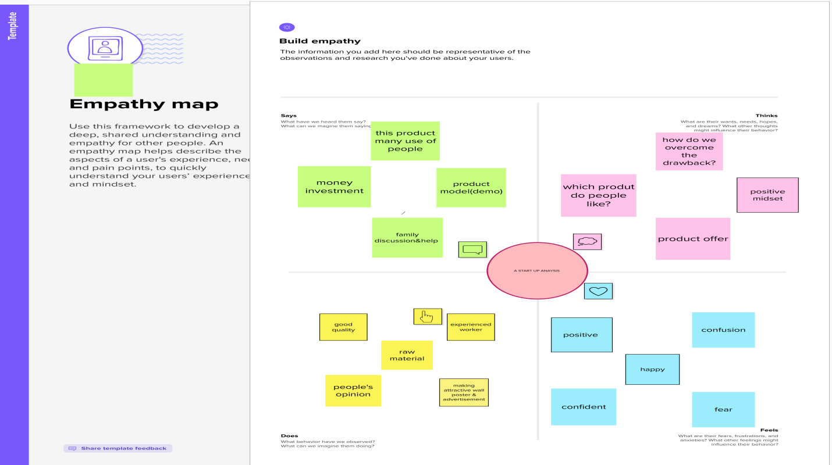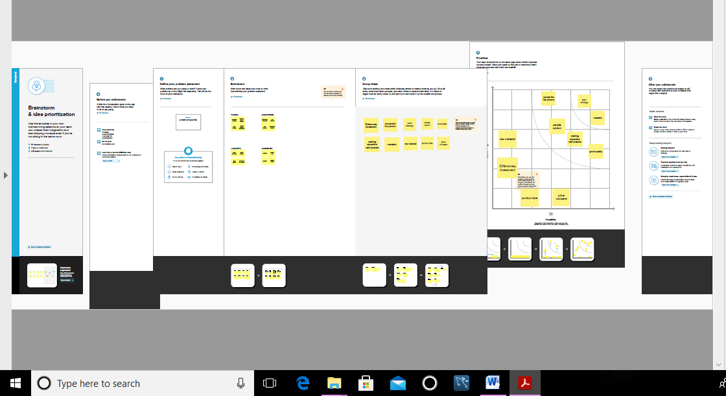

**3.RESULT:**

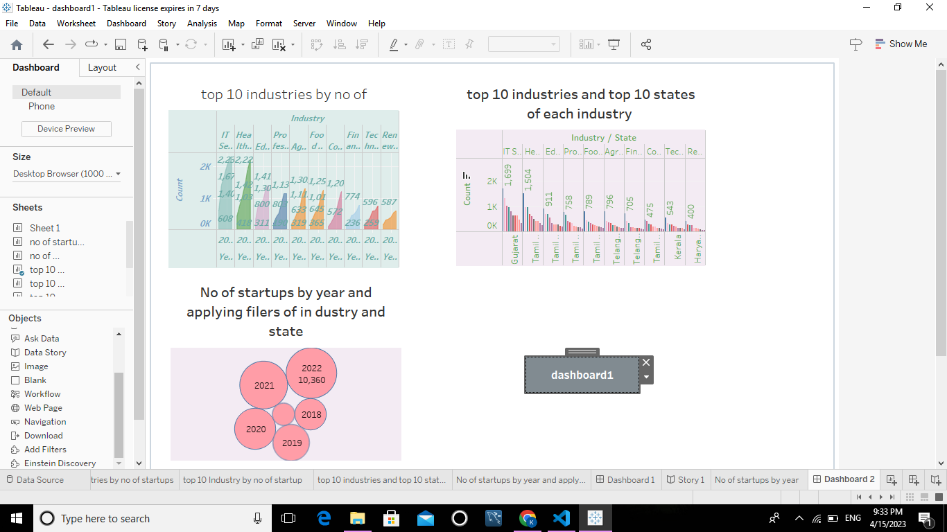

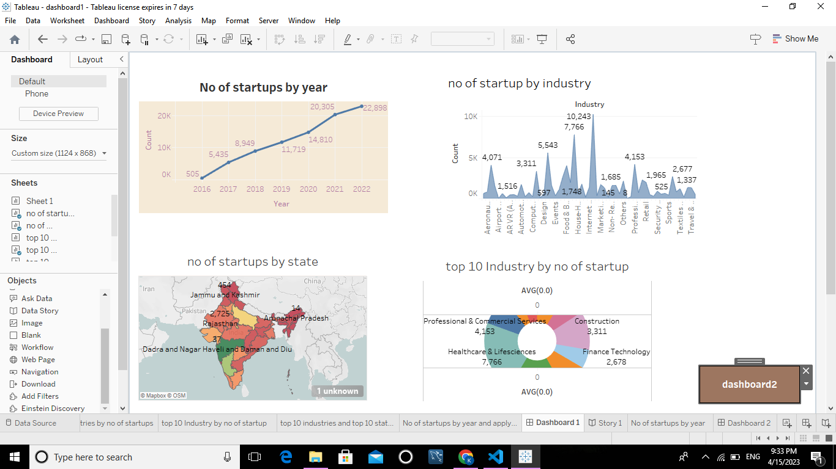

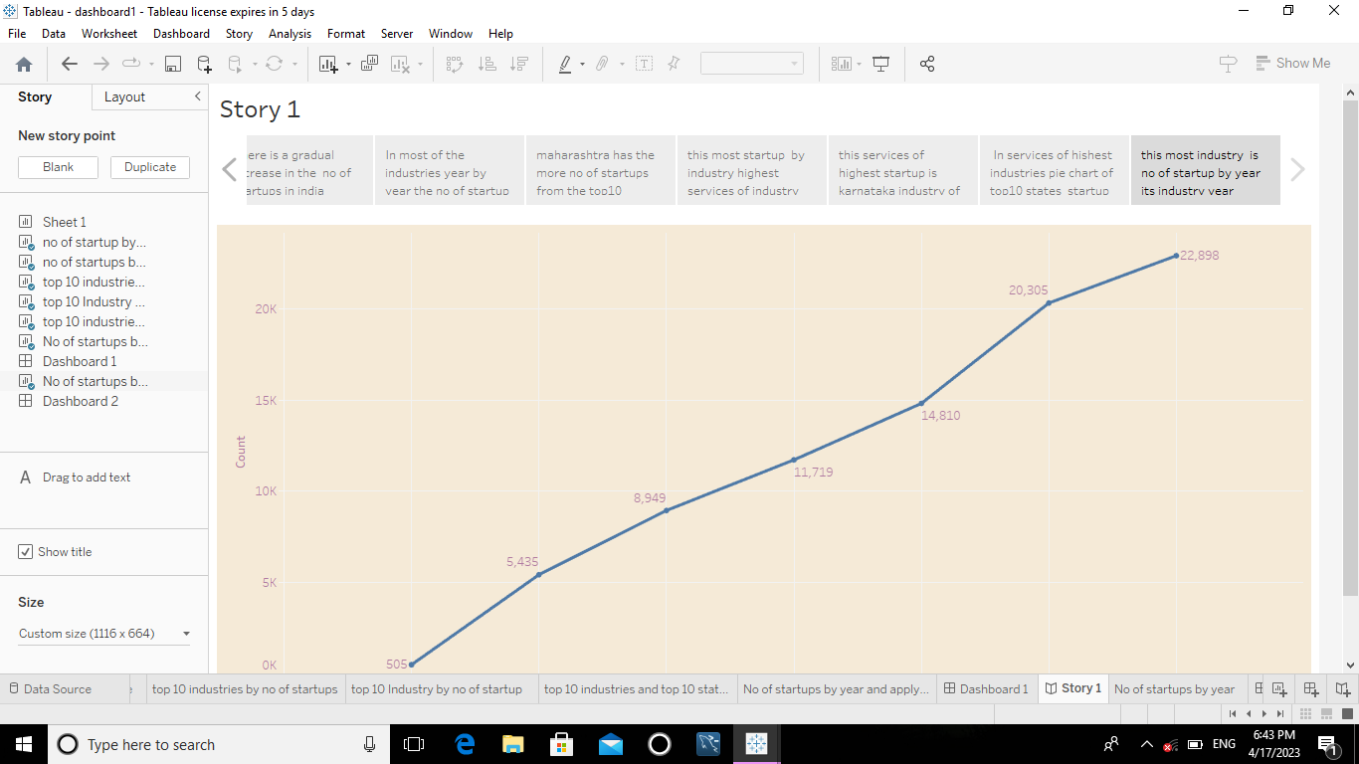

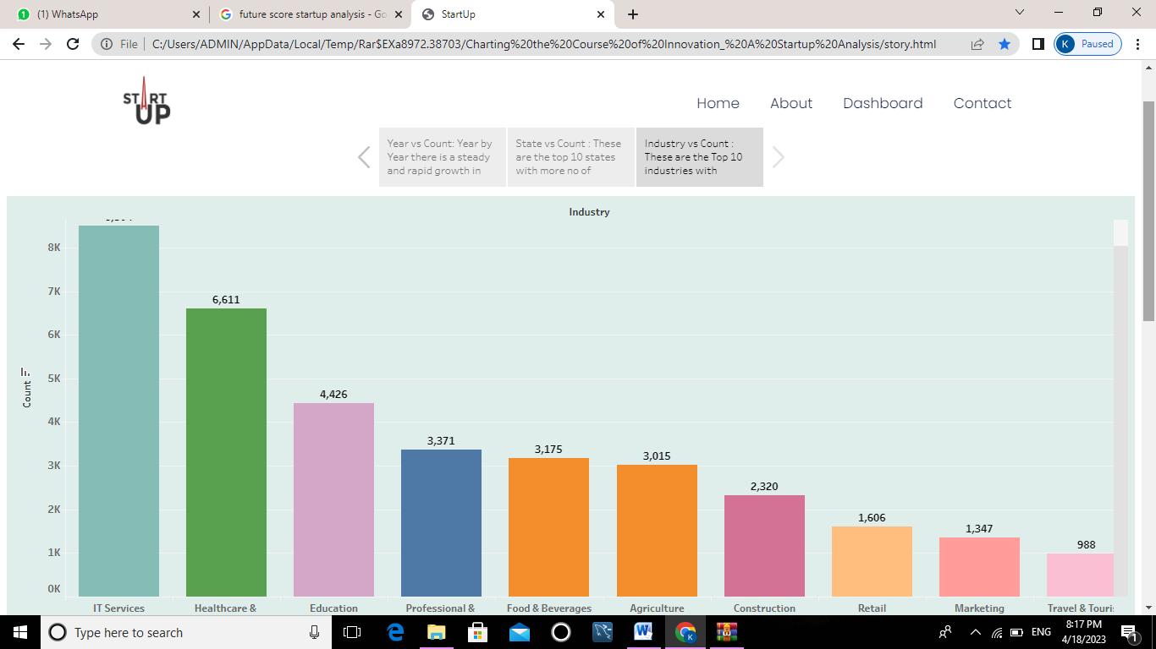

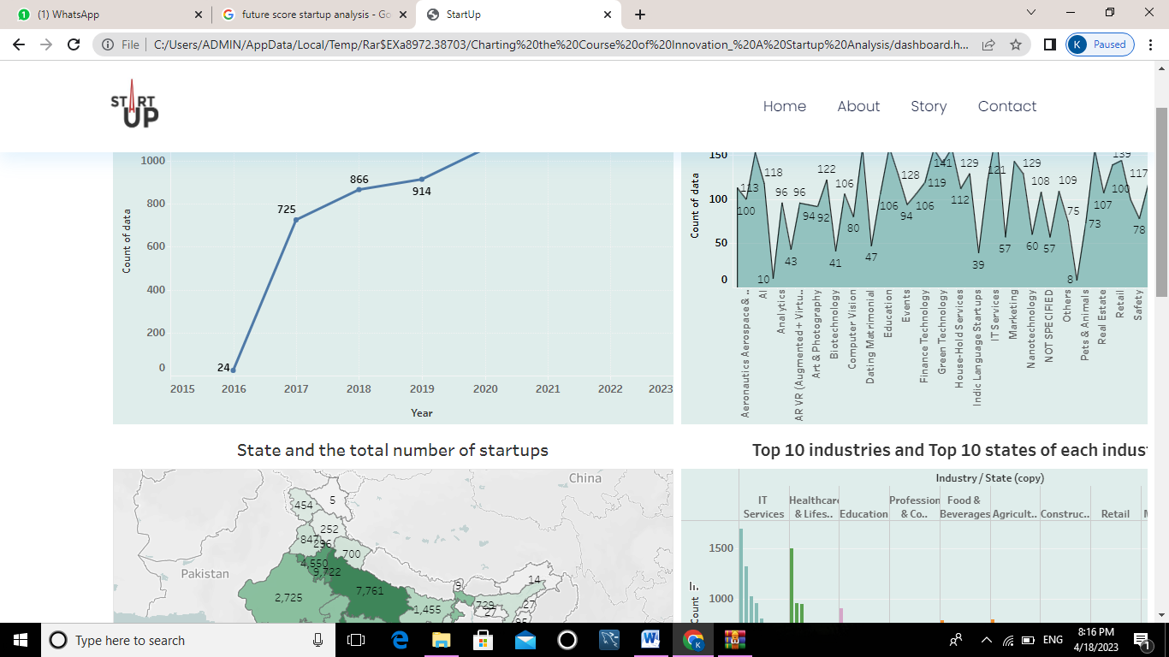

**4.ADVANTAGES & DISADVANTAGES:**

# 4.1.ADVANTAGES

* No pushback from established managers and employees who resist change.
* No incentive bonuses to keep experienced employees on board.
* No old equipment to upgrade.
* No delinquent clients to worry about .
* No negative reviews online to haunt you .
* No logos, signs, stationary ,desks or even potted plants to stare at every day that you never really like.

**4.2.DISADVANTAGES**

* Most startups fail within their first year of operations, so the risk of failure is high.
* Many customers prefer a business that they have worked with over a new startup.
* Evan then disagreements can creep in when the going gets tough.
* This exposes them to poor customer service, legal liability and financial losses.
* A heavy workload.

**5.APPLICATIONS:**

* Confirm that the resource-intensive operation is critical to app startup.
* Try to move long-running operations to the background , if possible.
* Use the Macrobenchmark library to measure the time taken by each operation , and identify blocks that take a long time to complete .

**6.CONCLUSION:**

From the above analysis, we can conclude that the year 2015, was a major year for the startups to grow , and it continued till 2016 November . After 2016 , the funding got a sharp decrease. Bangalore was kind of the best location for the startups and technology got a huge boost.

**7.FUTURE SCORE:**

* **The stage is set for India to realise its vision of becoming a USD5 trillion economy and global powerhouse .**
* **For a startup to succeed, there are generally three core components making up that success.**
* **A strong product, a well-researched go-to-market strategy, and a strong organizational culture.**
* **Each of these components can be a struggle to get right individually—and ensuring each of them works together can be even bigger.**

BY

P.KAMALI ,

A.KALAIYARASI ,

J.KALANITHI ,

A.KANIMOZHI .